SMART JOB DRIVE QUEUE MANAGEMENT SYSTEM

PROJECT REPORT
Submitted By
Shardha Hoddur

ACKNOWLEDGEMENT

The project “Smart Job Drive Queue Management System” is the project work carried out by Shardha Hoddur as a part of the academic requirements for the completion of the Bachelor of Science in Information Technology.
I would like to express my sincere gratitude to my project guide for providing valuable guidance, suggestions, and support throughout the development of this project. Their guidance helped me understand the different stages of project development, including system analysis, design, coding, testing, and documentation.
I am also thankful to my teachers and college for providing the necessary knowledge and resources required to complete this project successfully.
Finally, I would like to thank my family and friends for their continuous support, encouragement, and motivation throughout the development of this project.

ABSTRACT

The Smart Job Drive Queue Management System is a web-based application developed to manage candidates during job drives in an organized and efficient manner. Traditional job drives often require candidates to stand in physical queues and wait for their turn, which can result in crowding, confusion, and unnecessary waiting time.
The proposed system provides a digital queue management solution where candidates can register themselves through an online form and receive an automatically generated token number. Candidates can then track their queue position, view the currently serving token, see the number of candidates ahead of them, and check their estimated waiting time.
The system also provides an HR/Admin dashboard for managing the candidate queue. HR can view registered candidates, monitor their status, call the next candidate, and mark candidates as completed or skipped. The system maintains candidate information and queue status using a database, allowing the queue to be managed in a structured manner.
The project is developed using HTML, CSS, and JavaScript for the frontend and Python Django with Django REST Framework for the backend. SQLite is used as the database. The system provides a simple, user-friendly, and efficient approach to managing job-drive queues digitally.

- INTRODUCTION

In today's digital age, technology plays an important role in improving the way organizations manage information and services. Web-based applications have made it possible to perform various activities digitally, reducing the dependency on traditional manual processes and improving efficiency.
Job drives and recruitment events are commonly conducted where a large number of candidates arrive at the same location for registration, aptitude tests, interviews, and other selection processes. When these activities are managed manually, candidates may have to wait in physical queues for long periods of time. This can result in overcrowding, confusion regarding candidate order, difficulty in managing the queue, and inefficient use of time.
The Smart Job Drive Queue Management System is developed to provide a digital solution to this problem. Instead of maintaining a completely physical queue, candidates can register through the website and receive a unique token number. The system maintains the candidate queue and allows candidates to track their position digitally.
The candidate can view important queue information such as the current token being served, the number of candidates ahead, estimated waiting time, and the current status of their application. This allows candidates to stay informed without continuously standing in a physical queue.
The system also provides an HR/Admin dashboard through which the recruitment team can manage the queue. HR can view registered candidates, call the next candidate, monitor the current serving candidate, and update candidate status after the interview.
The application uses HTML, CSS, and JavaScript for the frontend, while Python Django and Django REST Framework are used to handle the backend APIs and application logic. SQLite is used for storing candidate information and queue data.
The main purpose of this project is to make job-drive queue management more organized, transparent, and convenient for both candidates and HR personnel.

- OBJECTIVE

OBJECTIVE OF THE PRESENT WORK

The main objectives of the Smart Job Drive Queue Management System are as follows:
- To develop a web-based system for managing candidates during job drives.
- To replace or reduce the dependency on traditional physical queues during recruitment events.
- To provide candidates with an automatically generated token number after registration.
- To allow candidates to digitally track their queue position and current status.
- To display the number of candidates ahead of a particular candidate.
- To provide an estimated waiting time based on the candidate's position in the queue.
- To provide HR/Admin with a dashboard for monitoring and managing candidates.
- To allow HR to call the next candidate in the queue.
- To allow HR to mark candidates as completed or skipped after their interview.
- To maintain candidate information and queue status in a structured database.
- To reduce confusion, overcrowding, and unnecessary waiting during job drives.
- To provide a simple, user-friendly, and efficient digital queue management solution.

- SYSTEM ANALYSIS

PROBLEM DEFINITION

Traditional job drives and recruitment events often involve a large number of candidates waiting for registration, document verification, aptitude tests, or interviews. In many cases, candidates have to stand in physical queues and wait for their turn.
Managing a large physical queue manually can create several problems such as overcrowding, confusion about candidate order, difficulty in tracking candidates, and unnecessary waiting time. HR personnel also need to manually manage the sequence of candidates and update their status after each interview.
Candidates may not know how many people are ahead of them or approximately how long they need to wait. This can make the recruitment process less organized and inconvenient for both candidates and HR.
The Smart Job Drive Queue Management System solves these problems by providing a digital queue management system. Candidates can register online, receive an automatically generated token number, and track their position in the queue. HR can manage the queue through a dashboard and update candidate statuses during the recruitment process.

PRELIMINARY INVESTIGATION
Purpose
The purpose of the Smart Job Drive Queue Management System is to provide a simple digital method for managing candidates during job drives.
The system reduces dependency on physical queues by allowing candidates to register and receive tokens digitally. It also provides HR personnel with a centralized dashboard for monitoring and controlling the candidate queue.
Benefits
The proposed system provides several advantages:
- Digital Registration: Candidates can register through an online form instead of registering manually.
- Automatic Token Generation: A unique token number is automatically assigned to each registered candidate.
- Queue Tracking: Candidates can view their current queue position and monitor the progress of the queue.
- Candidates Ahead: The system displays the number of candidates currently ahead of the candidate.
- Estimated Waiting Time: Candidates can get an approximate waiting time based on their queue position.
- Reduced Crowding: Candidates do not need to continuously stand in a physical queue.
- HR Dashboard: HR can view and manage registered candidates from a centralized dashboard.
- Queue Management: HR can call the next candidate and update the candidate's status.
- Status Management: Candidates can be marked as Waiting, Serving, Completed, or Skipped.
- Centralized Data: Candidate information and queue status are stored in a database.
Proposed System
The proposed Smart Job Drive Queue Management System provides a structured and digital approach to job-drive queue management.
The system consists mainly of two sides:
1. Candidate Side
Candidates can:
- Register for the job drive.
- Enter their personal and job-related information.
- Receive an automatically generated token.
- View their token number.
- Check the current serving token.
- See the number of candidates ahead.
- View estimated waiting time.
- Track their queue progress.
- View their current status.
2. HR/Admin Side
HR personnel can:
- Access the HR dashboard.
- View total registered candidates.
- View waiting candidates.
- View completed candidates.
- View the current serving token.
- View the complete candidate queue.
- Call the next candidate.
- Complete a serving candidate.
- Skip a serving candidate.
- Monitor candidate statuses.
FEASIBILITY STUDY
The feasibility study evaluates whether the Smart Job Drive Queue Management System is practical and achievable using the available technology and resources.
The project can be evaluated using the following types of feasibility analysis.
3.3.1 Technical Feasibility
The system is technically feasible because it uses commonly available web technologies.
- The frontend is developed using HTML, CSS, and JavaScript.
- The backend is developed using Python Django and Django REST Framework.
- SQLite is used for storing candidate and queue information.
- REST APIs are used for communication between the frontend and backend.
- The application can be run on a standard computer using a local development environment.
- The technologies used are open-source and do not require expensive software licenses.
3.3.2 Economic Feasibility
The system is economically feasible because it is developed using free and open-source technologies.
- Python and Django are open-source.
- Django REST Framework is freely available.
- SQLite does not require a separate database server.
- HTML, CSS, and JavaScript do not require paid development tools.
- The system can reduce the need for manual queue-management resources during job drives.
Therefore, the development cost of the basic system is low.
3.3.3 Operational Feasibility
The system is operationally feasible because it is designed to be simple and easy to use.
- Candidates can register using a simple web form.
- Token numbers are generated automatically.
- Candidates can monitor their queue digitally.
- HR can manage the queue from a dashboard.
- The system reduces manual queue-management work.
- The interface provides clear information about candidate status.
3.3.4 Schedule Feasibility
The project can be developed within an academic project timeline by dividing development into different stages.
The major stages include:
- Requirement Analysis
- System Design
- Frontend Development
- Backend Development
- Database Integration
- API Integration
- Testing and Debugging
- Documentation
The modular development approach allows each part of the system to be developed and tested separately.

3.4 PROJECT PLANNING
Project planning provides a structured approach for developing the Smart Job Drive Queue Management System. It helps organize the requirements, development activities, testing, and final documentation.
Phases Covered in the Plan
1. Preliminary Investigation
Understanding the problems associated with traditional physical queues during job drives.
2. Requirement Analysis
Identifying the requirements of candidates and HR personnel and deciding the major features of the system.
3. System Design
Designing the system architecture, database structure, modules, API endpoints, and user interface.
4. Frontend Development
Developing the candidate registration page, queue tracking interface, and HR dashboard using HTML, CSS, and JavaScript.
5. Backend Development
Developing the backend using Python Django and Django REST Framework.
6. Database Integration
Creating the candidate database structure and connecting the backend with SQLite.
7. API Integration
Connecting the frontend with backend APIs for registration, queue management, candidate status, and dashboard statistics.
8. Testing
Testing individual functions as well as the complete system to identify and fix errors.
9. Documentation
Preparing the final project report, screenshots, coding section, testing results, and other required documentation.
3.5 SOFTWARE REQUIREMENT SPECIFICATION (SRS)
The Software Requirement Specification describes the basic requirements of the Smart Job Drive Queue Management System and defines what the system should provide to its users.
System Overview
The Smart Job Drive Queue Management System is a web-based application designed to digitally manage candidates during job drives.
The system consists of two main modules:

1. Candidate Module
This module allows candidates to register and monitor their position in the recruitment queue.

2. HR/Admin Module
This module allows HR personnel to monitor and manage candidates and control the queue.

Software Requirements :
Component | Technology
Frontend | HTML, CSS, JavaScript
Backend | Python Django
API Framework | Django REST Framework
Database | SQLite
Code Editor | Visual Studio Code
Operating System | Windows
Browser | Google Chrome / Modern Web Browser

Hardware Requirements
The basic system can run on a standard computer.
- Processor: Intel i3 or equivalent and above
- RAM: Minimum 4 GB
- Storage: Minimum 10 GB available space
- Display: Standard monitor
- Keyboard and Mouse: Required
- Internet: Required for online deployment; local development can operate without external internet access once the required software is installed.
3.6 FUNCTIONAL REQUIREMENTS
The functional requirements describe the operations that the system should perform.

1. Candidate Module
Candidates can:
- Register for the job drive.
- Enter name, email, phone, college, and position details.
- Receive an automatically generated token number.
- View their assigned token.
- Track the current serving token.
- View candidates ahead in the queue.
- View estimated waiting time.
- Monitor queue progress.
- View their current status.

2. HR/Admin Module
HR can:
- View the HR dashboard.
- View total number of candidates.
- View waiting candidates.
- View completed candidates.
- View the current serving token.
- View the candidate queue.
- Call the next waiting candidate.
- Complete a serving candidate.
- Skip a serving candidate.
- Monitor candidate status.

3. Queue Management
The system can:
- Automatically generate sequential token numbers.
- Maintain candidates according to their token order.
- Identify the next waiting candidate.
- Allow only one candidate to be in the Serving state at a time.
- Update candidate status after an HR action.
- Calculate the number of candidates ahead.
- Calculate estimated waiting time.

3.7 SOFTWARE ENGINEERING PARADIGM
The development of the Smart Job Drive Queue Management System follows a structured software development approach.
Development Model: Waterfall Model with Iterative Testing
The project follows a structured sequence of development activities, beginning with requirement analysis and continuing through design, implementation, testing, and documentation.
The major stages are:

- Requirement Analysis – Understanding the job-drive queue problem and identifying system requirements.
- System Design – Designing the user interface, database, modules, and API structure.
- Implementation – Developing the frontend and backend components.
- Database Integration – Connecting the application with the SQLite database.
- Testing and Debugging – Testing individual features and the complete application and correcting errors.
- Documentation – Preparing the final project report and supporting documentation.

3.8 DATA FLOW DIAGRAM (DFD)
A Data Flow Diagram represents how data moves through the Smart Job Drive Queue Management System. It shows the external users, major processes, data storage, and flow of information between them.
Level 0 DFD / Context Diagram
Level 1 DFD

3.8.1 LEVEL 0 DFD / CONTEXT DIAGRAM
At Level 0, the complete Smart Job Drive Queue Management System is represented as a single process. The two main external entities are:
- Candidate
- HR/Admin
Candidate → System
- Registration details
- Queue tracking request
System → Candidate
- Token number
- Current token
- Candidates ahead
- Estimated waiting time
- Queue status
HR/Admin → System
- Call next candidate
- Complete candidate
- Skip candidate
- Queue management requests
System → HR/Admin
- Candidate information
- Queue status
- Statistics
- Current serving candidate

3.8.2 LEVEL 1 DFD
The Level 1 DFD expands the main system into its major processes.
For our project, we can divide the system into four major processes:
Process 1.0 – Candidate Registration
Candidate enters:
- Name
- Email
- Phone
- College
- Position
The system validates the information and generates a unique token number.
Output:
- Candidate registration
- Token number

Process 2.0 – Queue Management
This process manages the candidate queue.
It handles:
- Waiting candidates
- Current serving candidate
- Next candidate
- Candidate order
- Queue status
The system ensures that the next waiting candidate can be called when no candidate is currently being served.

Process 3.0 – Queue Tracking
Candidates can view:
- Their token
- Current serving token
- Candidates ahead
- Estimated waiting time
- Queue progress
- Candidate status
The information is retrieved from the queue data.

Process 4.0 – HR/Admin Management
HR/Admin can:
- View dashboard statistics
- View candidate queue
- Call next candidate
- Complete serving candidate
- Skip serving candidate
- Monitor candidate status

Data Store – Candidate Database
The database stores candidate information such as:
- Candidate name
- Email
- Phone
- College
- Position
- Token number
- Status
The database is implemented using SQLite in your project.
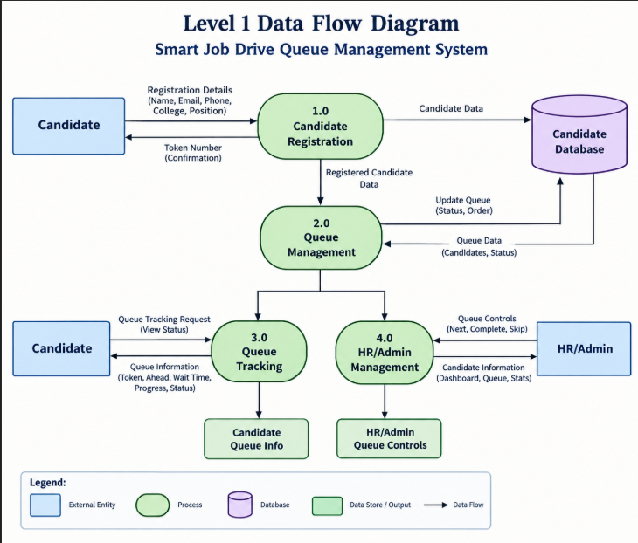

- SYSTEM DESIGN

4.1 MODULE
The Smart Job Drive Queue Management System is divided into two main modules:
1. Candidate Module
The Candidate Module allows candidates to register and digitally track their position in the job-drive queue.
Candidates can:
- Enter their name, email, phone number, college, and applied position.
- Register for the job drive through the online registration form.
- Receive an automatically generated token number.
- View their assigned token number.
- View the currently serving token.
- Check the number of candidates ahead in the queue.
- View the estimated waiting time.
- Monitor their queue progress.
- View their current status such as Waiting, Serving, Completed, or Skipped.
2. HR/Admin Module
The HR/Admin Module allows the recruitment team to manage the candidate queue.
HR/Admin can:
- View the total number of registered candidates.
- View the number of waiting candidates.
- View completed candidates.
- View the current serving token.
- View the complete candidate queue.
- Call the next candidate.
- View the candidate who is currently being interviewed.
- Mark a serving candidate as Completed.
- Mark a serving candidate as Skipped.
- Monitor candidate status through the dashboard.

4.2 DATA STRUCTURE OF THE MODULE
The Smart Job Drive Queue Management System uses SQLite as its database.
The main database table used by the project is the Candidate table. It stores the information required for candidate registration and queue management.

Candidate Table
Field Name | Description
id | Unique identifier of the candidate
name | Name of the candidate
email | Email address of the candidate
phone | Contact number
college | Candidate's college name
position | Position applied for
token_number | Automatically generated queue token
status | Current queue status

Status Values
The system uses the following candidate statuses:
- Waiting – Candidate is registered and waiting for their turn.
- Serving – Candidate is currently being interviewed.
- Completed – Candidate's interview has been completed.
- Skipped – Candidate was skipped by HR/Admin.
The candidate table acts as the main data source for both the Candidate Module and HR/Admin Module.

4.3 PROCEDURAL DESIGN
Procedural design describes the sequence of steps followed by different modules of the Smart Job Drive Queue Management System.
The main processes of the system are:
- Candidate Registration
- Token Generation
- Queue Tracking
- HR/Admin Queue Management
- Candidate Completion

4.3.1 CANDIDATE REGISTRATION FLOW
The candidate registration process follows these steps:
- Candidate opens the Smart Job Drive website.
- Candidate enters the required registration details.
- The system validates the entered information.
- The registration data is sent to the Django backend.
- The system generates the next available token number.
- Candidate information and token number are stored in the database.
- The generated token is displayed to the candidate.
- Candidate can then track their queue.

Flow:
START
↓
Open Website
↓
Enter Candidate Details
↓
Submit Registration
↓
Validate Details
↓
Generate Token Number
↓
Store Candidate in Database
↓
Display Token Number
↓
Track Queue
↓
END

4.3.2 QUEUE TRACKING FLOW
After registration, the candidate can track their queue position.
The system retrieves the latest queue information from the database and displays:
- Candidate's token
- Current serving token
- Candidates ahead
- Estimated waiting time
- Queue progress
- Candidate status

Flow:
START
↓
Candidate Registered?
↓
Fetch Queue Data
↓
Find Current Serving Candidate
↓
Find Candidate's Position
↓
Calculate Candidates Ahead
↓
Calculate Estimated Waiting Time
↓
Display Queue Information
↓
END

4.3.3 HR/ADMIN PANEL DESIGN
The HR/Admin dashboard provides the recruitment team with a centralized interface for managing the queue.
The HR/Admin can view candidate information and queue statistics. When there is no candidate currently being served, HR can select Call Next Candidate.
The selected candidate's status changes from Waiting to Serving.
After the interview, HR can mark the candidate as:
- Completed, or
- Skipped

The queue is then updated accordingly.

Flow:

START
↓
Open HR/Admin Dashboard
↓
View Candidate Queue
↓
Is a Candidate Currently Serving?
↓
NO
↓
Call Next Candidate
↓
Candidate Status = Serving
↓
Conduct Interview
↓
Complete / Skip Candidate
↓
Update Database
↓
Refresh Queue
↓
END

4.3.4 QUEUE MANAGEMENT LOGIC
The queue management process follows the token order.
When HR selects Call Next Candidate, the system:
- Checks whether a candidate is already being served.
- If a candidate is already serving, another candidate cannot be called.
- If no candidate is serving, the system finds the first candidate with Waiting status.
- That candidate is changed to Serving.
- The current token is updated on the dashboard.
- After the interview, HR can complete or skip the candidate.
- The next waiting candidate can then be called.
This ensures that only one candidate is in the Serving/Interviewing state at a time.
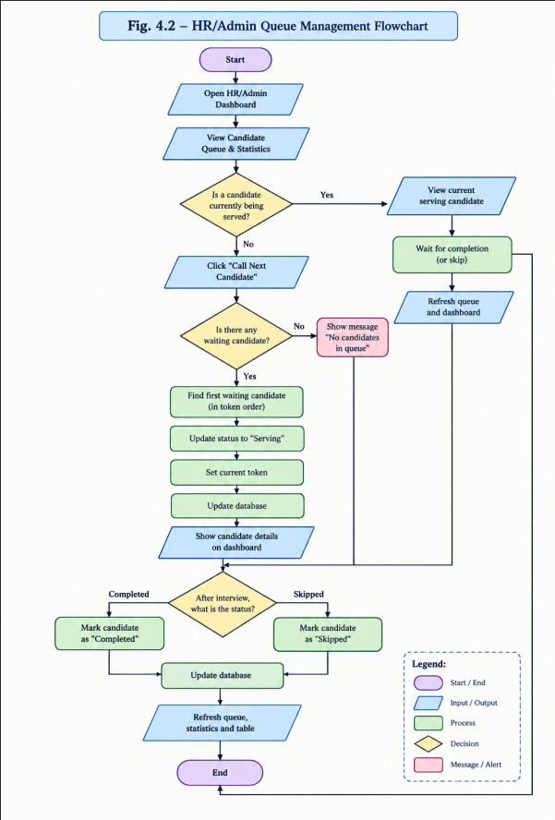
- SCREENSHOTS

5.1 HOME PAGE
The Home Page is the main landing page of the Smart Job Drive Queue Management System. It introduces the purpose of the system and provides navigation to the registration and queue sections.

Fig. 5.1: Home Page of Smart Job Drive Queue Management System

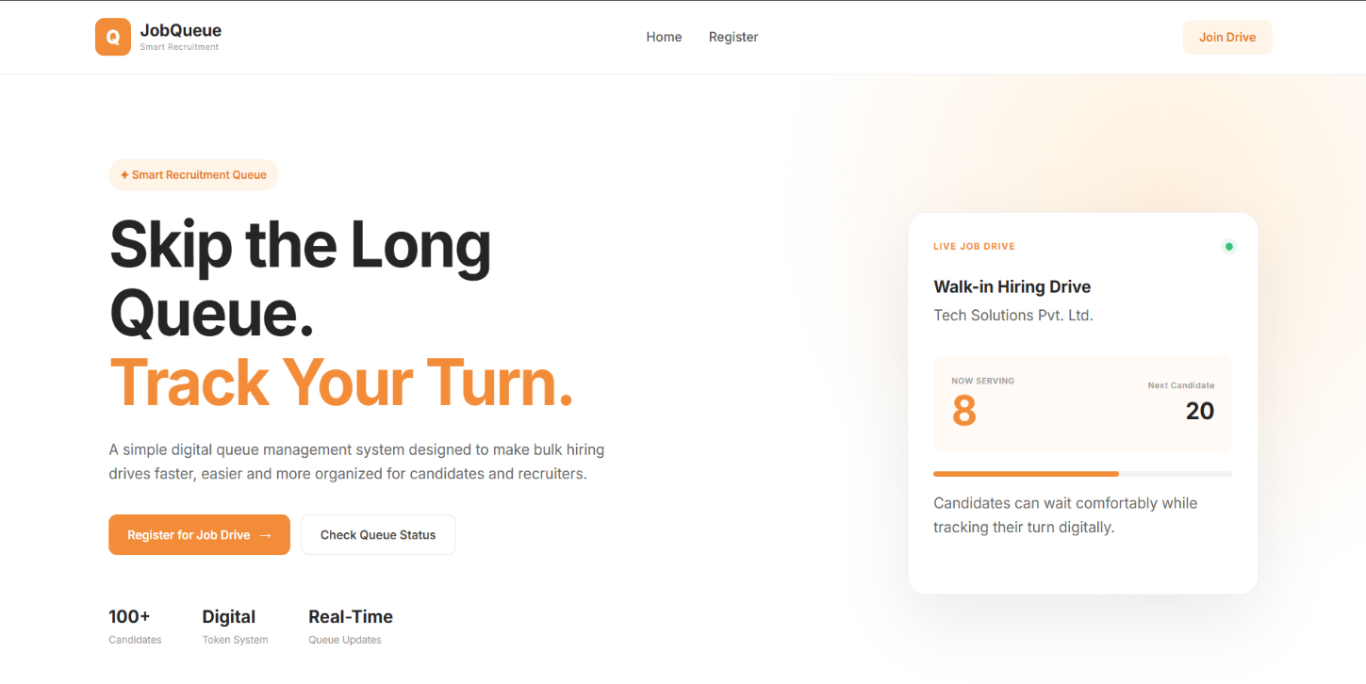
5.2 CANDIDATE REGISTRATION
The Candidate Registration section allows candidates to enter their personal and job-related information. After submitting the form, the system generates an automatic token number for the candidate.

Fig. 5.2: Candidate Registration Page
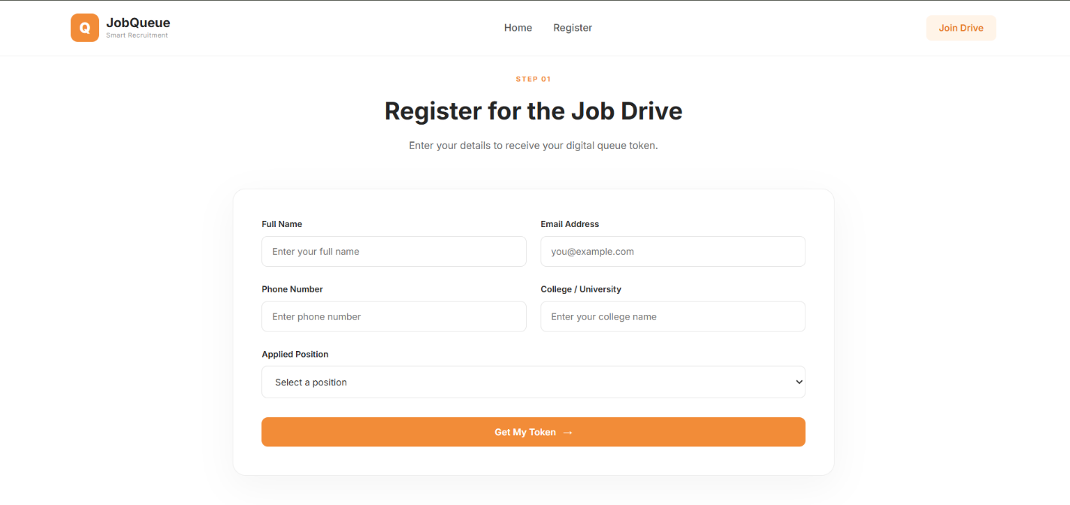
5.3 TOKEN GENERATION
After successful registration, the system displays the automatically generated token number assigned to the candidate.

Fig. 5.3: Candidate Token Generation

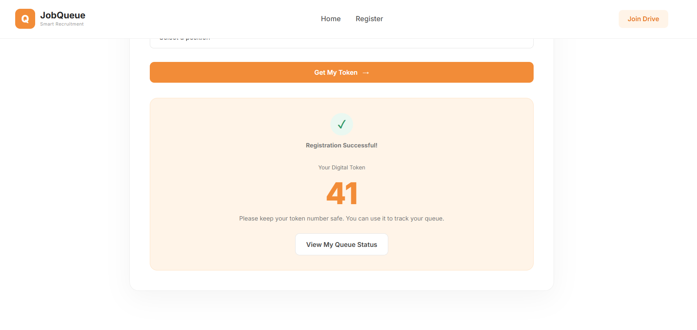

5.4 QUEUE TRACKING
The Queue Tracking section allows candidates to monitor their position without standing continuously in a physical queue.
It displays:
- Your Token
- Current Token
- Candidates Ahead
- Estimated Wait
- Queue Progress
- Candidate Status

Fig. 5.4: Candidate Queue Tracking

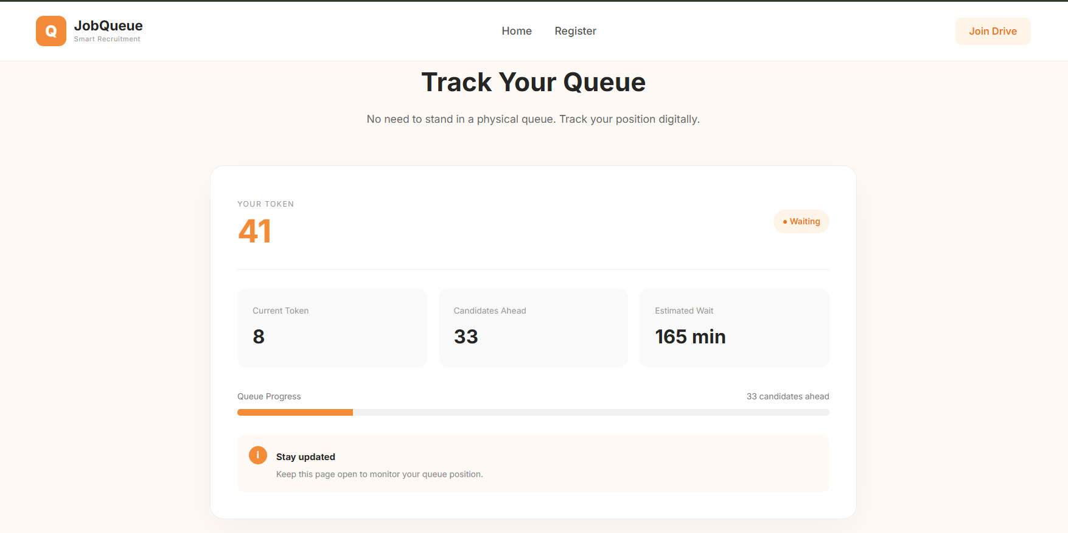

5.5 HR/ADMIN DASHBOARD

The HR/Admin Dashboard provides a centralized interface for managing the recruitment queue.
It displays:
- Total Candidates
- Waiting Candidates
- Completed Candidates
- Current Token
- Candidate Queue
- Candidate Status
- Action buttons

Fig. 5.5: HR/Admin Login & Dashboard

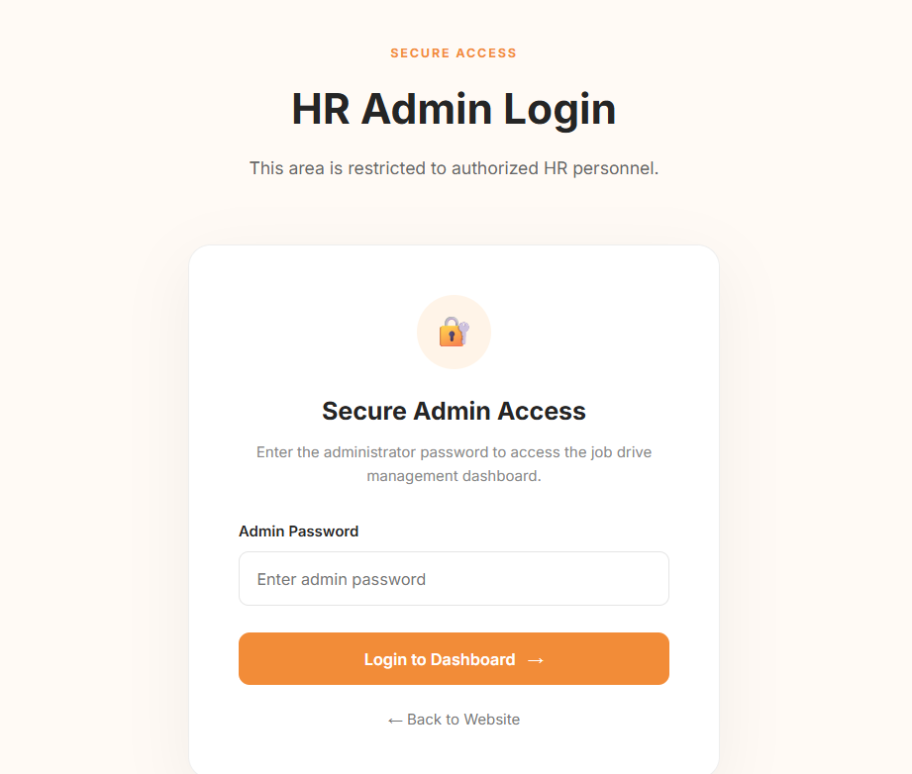

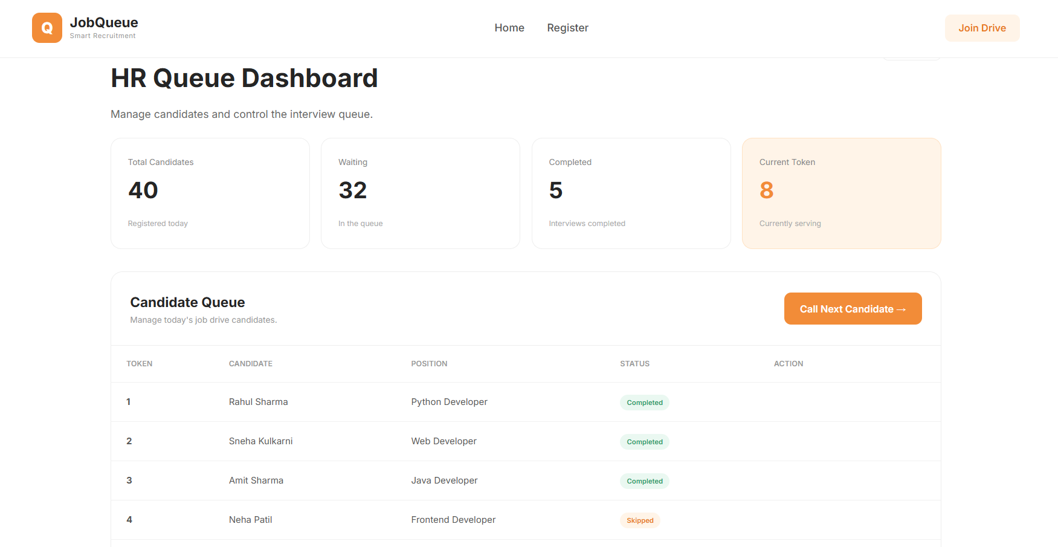

- CODING

6.1 Candidate Registration Code

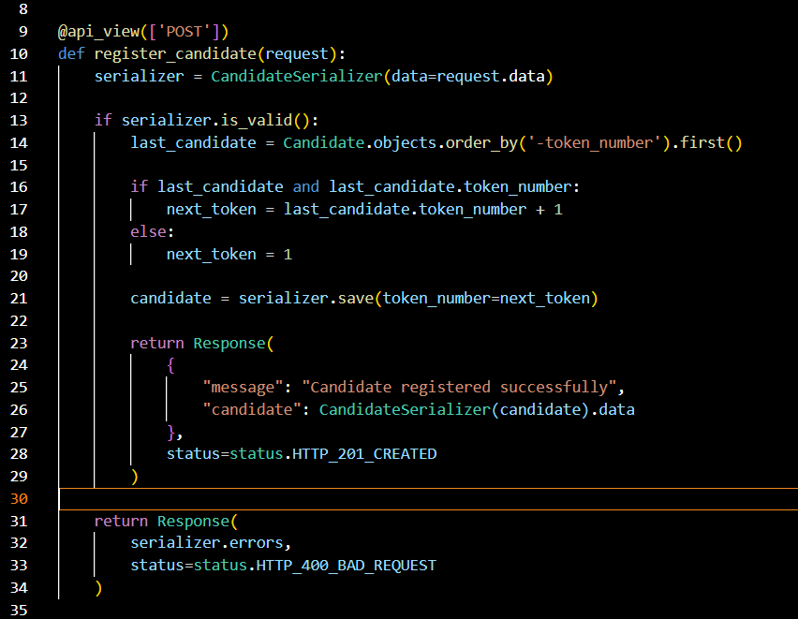

6.2 Automatic Token Generation

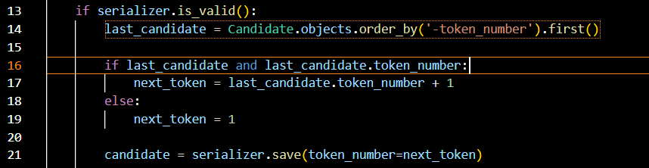

6.3 Queue Management / Call Next Candidate
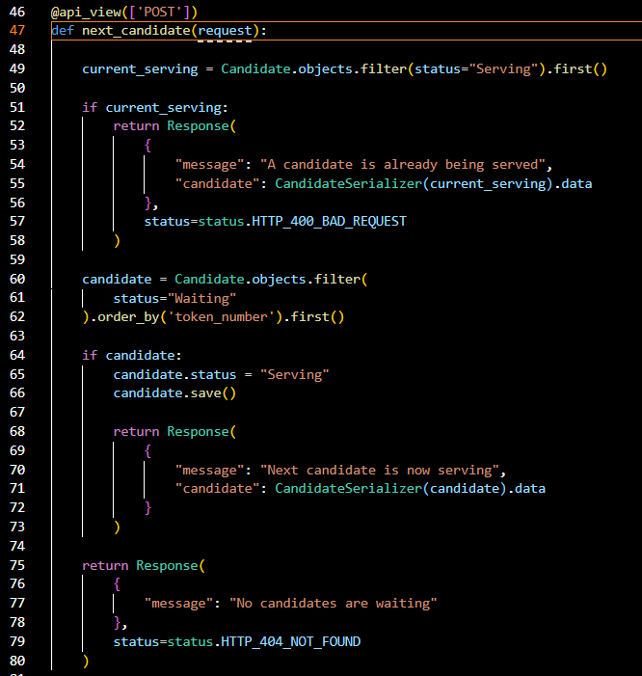

6.4 Complete Candidate

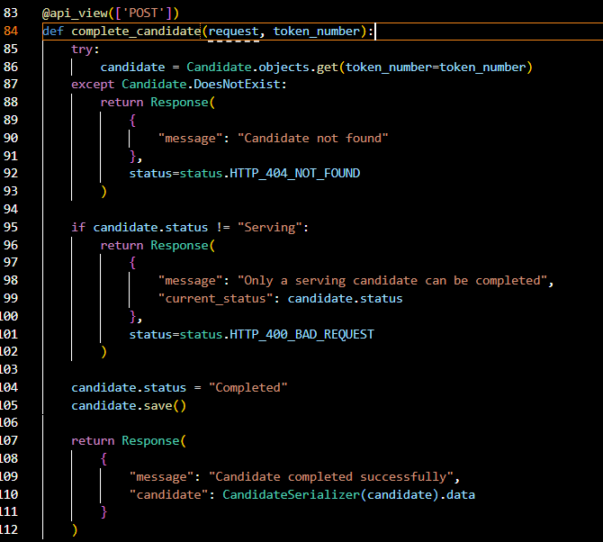
6.5 Frontend API Integration

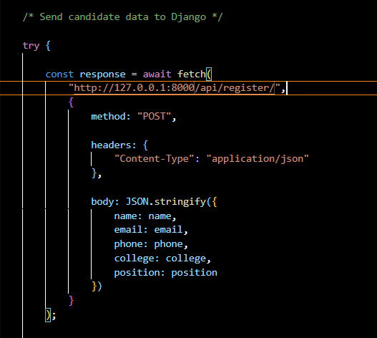

7. TESTING

The system was tested for candidate registration, token generation, queue tracking, HR/Admin queue management, status updates, and dashboard statistics.

7.1 TESTING METHODS
The following testing methods were used:
1. Functional Testing
Functional testing was performed to check whether each feature of the system works according to the specified requirements.
2. Integration Testing
Integration testing was performed to verify communication between the frontend, Django REST API, and SQLite database.
3. User Interface Testing
The interface was tested to ensure that candidate and HR/Admin features are displayed correctly and are easy to use.

7.2 TEST CASES

Test Case | Test Description | Expected Result | Status
TC01 | Open the website | Home page should load successfully | Pass
TC02 | Submit candidate registration form | Candidate should be registered successfully | Pass
TC03 | Register a new candidate | A sequential token number should be generated | Pass
TC04 | View Queue Status after registration | Candidate token and queue information should be displayed | Pass
TC05 | Check candidates ahead | Number of candidates ahead should be displayed | Pass
TC06 | Check estimated waiting time | Estimated waiting time should be displayed | Pass
TC07 | Open HR/Admin dashboard | Dashboard should display correctly | Pass
TC08 | View candidate queue | Registered candidates should be displayed | Pass
TC09 | Click Call Next Candidate | First waiting candidate should become Serving/Interviewing | Pass
TC10 | Call Next while another candidate is Serving | System should prevent another candidate from being called | Pass
TC11 | Complete serving candidate | Candidate status should change to Completed | Pass
TC12 | Skip serving candidate | Candidate status should change to Skipped | Pass
TC13 | View dashboard statistics | Total, waiting, completed and current token values should update | Pass
TC14 | Refresh queue after status change | Queue and candidate table should display updated information | Pass

7.3 TESTING RESULT

The testing results show that the major functions of the Smart Job Drive Queue Management System are working as expected.
Candidate registration successfully stores candidate information and generates a token number. The queue tracking feature displays the candidate's token, current token, candidates ahead, estimated waiting time, and queue progress.
The HR/Admin dashboard successfully displays candidate information and queue statistics. The Call Next Candidate, Complete, and Skip operations correctly update the candidate's status and refresh the queue.
Therefore, the implemented system successfully satisfies the major functional requirements of the proposed Smart Job Drive Queue Management System.

8. REPORT

The Smart Job Drive Queue Management System was developed as a web-based solution to improve the management of candidates during job drives and recruitment events.
The system provides a digital alternative to traditional physical queues. Candidates can register through the website and receive an automatically generated token number. After registration, candidates can track their queue position, current serving token, number of candidates ahead, estimated waiting time, and current status.
The HR/Admin module provides a centralized dashboard for managing the recruitment queue. HR/Admin can view candidate details, monitor queue statistics, call the next waiting candidate, and update the candidate's status after the interview.
The system was implemented using HTML, CSS, and JavaScript for the frontend and Python Django with Django REST Framework for the backend. SQLite was used to store candidate information and queue-related data.
The major functions implemented in the system include:
- Candidate registration
- Automatic token generation
- Digital queue tracking
- Current token display
- Candidates-ahead calculation
- Estimated waiting time
- Queue progress display
- HR/Admin dashboard
- Candidate queue management
- Call Next Candidate
- Complete Candidate
- Skip Candidate
- Queue statistics
- Candidate status management
The system was tested using different test cases to verify the functionality of the candidate and HR/Admin modules. The testing results showed that the major features of the system worked as expected.

The project successfully achieved its main objective of developing a digital queue management system for job drives.
The final system provides:
Candidate Side → Registration → Token → Queue Tracking → Status
HR/Admin Side → Dashboard → Call Next → Interview → Complete/Skip → Queue Update
The developed system can serve as a basic prototype for managing candidates during recruitment drives and can be further enhanced with additional features in the future.

9. FUTURE SCOPE
The Smart Job Drive Queue Management System can be further improved and expanded to support larger recruitment events and provide additional functionality.
The possible future enhancements of the system are:
- Online Notifications: Candidates can receive notifications when their turn is approaching.
- SMS/Email Alerts: The system can send token and interview updates through SMS or email.
- Multiple Recruitment Drives: Different job drives can be managed separately within the same system.
- Multiple HR Panels: Multiple HR/interview panels can handle candidates simultaneously.
- Authentication: Secure login can be provided for HR/Admin users.
- Cloud Deployment: The system can be deployed on a cloud platform so that it can be accessed from different locations.
- Advanced Dashboard: Graphs and reports can be added to provide detailed recruitment statistics.
- Mobile-Friendly Interface: The system can be optimized further for smartphones and tablets.
- Candidate History: Previous recruitment records can be maintained for future reference.
- Estimated Waiting Time Improvement: Waiting time can be calculated dynamically based on actual interview duration instead of a fixed estimated time.
- Database Enhancement: A larger production-ready database can be used when the system is deployed for large-scale recruitment events.
These enhancements can make the system more scalable, reliable, and suitable for real-world recruitment environments.

10. CONCLUSION
The Smart Job Drive Queue Management System was developed to provide a simple and efficient digital solution for managing candidates during job drives and recruitment events.
The system reduces the dependency on traditional physical queues by allowing candidates to register online and receive an automatically generated token number. Candidates can track their queue position, current serving token, candidates ahead, estimated waiting time, and current status through the website.
The HR/Admin dashboard provides an organized way to manage the candidate queue. HR/Admin can view candidate information and queue statistics, call the next candidate, and update the candidate's status as Completed or Skipped.
The project was implemented using HTML, CSS, JavaScript, Python Django, Django REST Framework, and SQLite. The frontend and backend were integrated using REST APIs, allowing candidate and queue information to be updated dynamically.
Testing was performed on the major features of the system, and the results showed that the implemented functions work as expected.
Thus, the Smart Job Drive Queue Management System successfully achieves its objective of making job-drive queue management more organized, transparent, and convenient for both candidates and HR/Admin personnel.

